**Article ID:** 500 New a

**Article Name:** [1174]How to clean the filter

**Topic Location:** Laundry / Washing Machine/ Water / Emptying / Draining

**Meta-data:** empty, pump out, flow out, remove, pump of

**Related Articles:** Check Drain

**Related Questions:**

PNC

DIY

Safety

Link

Email

Book Engineer

Multimedia

Brand

**Article Content:**

**1132 – Check and Clean the Filter.**

**WSS:**

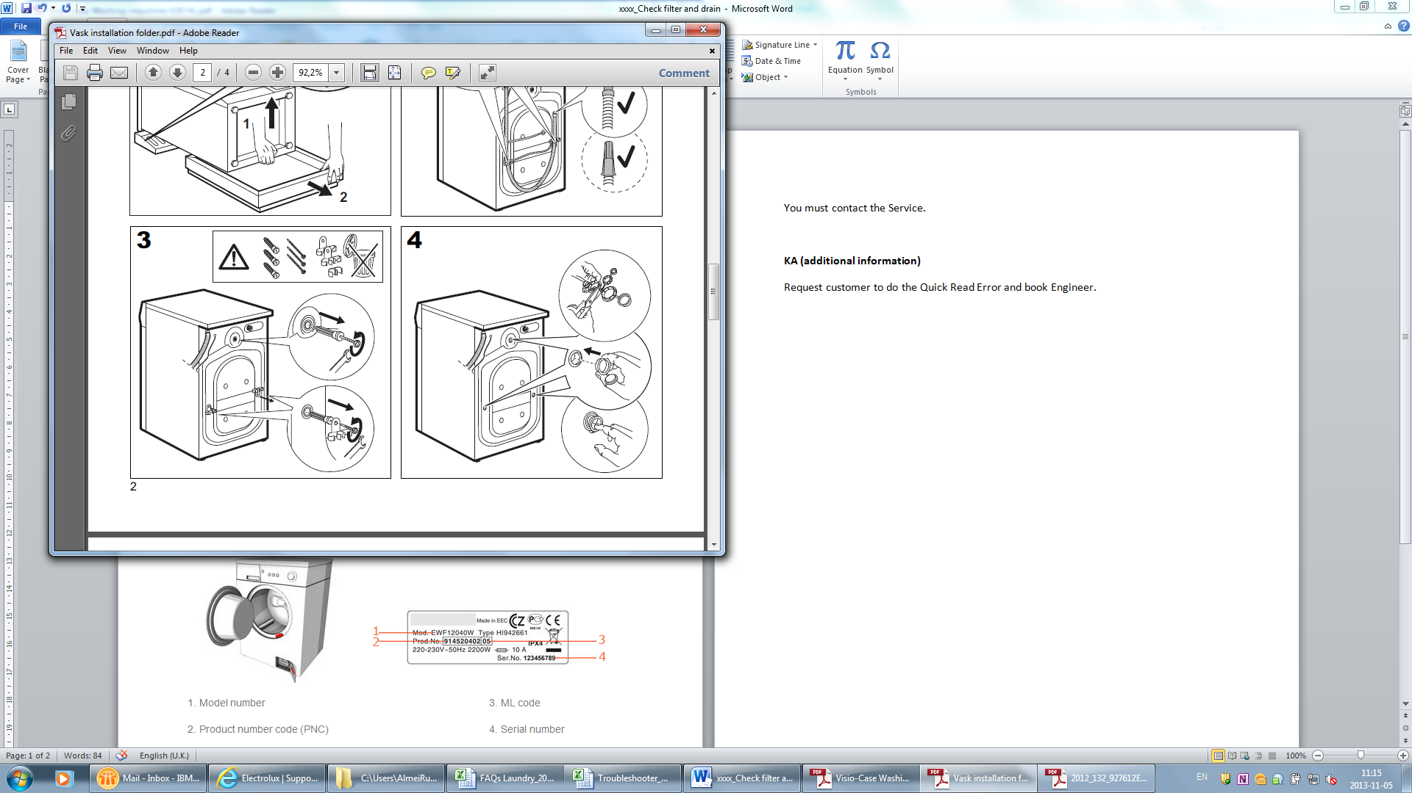

**WARNING** - Switch the appliance off and unplug it from power supply before you carry out any cleaning or maintenance. If necessary wait a few moments because the water inside the washing machine might be hot!

**Washing machines (filters at bottom of het front)**

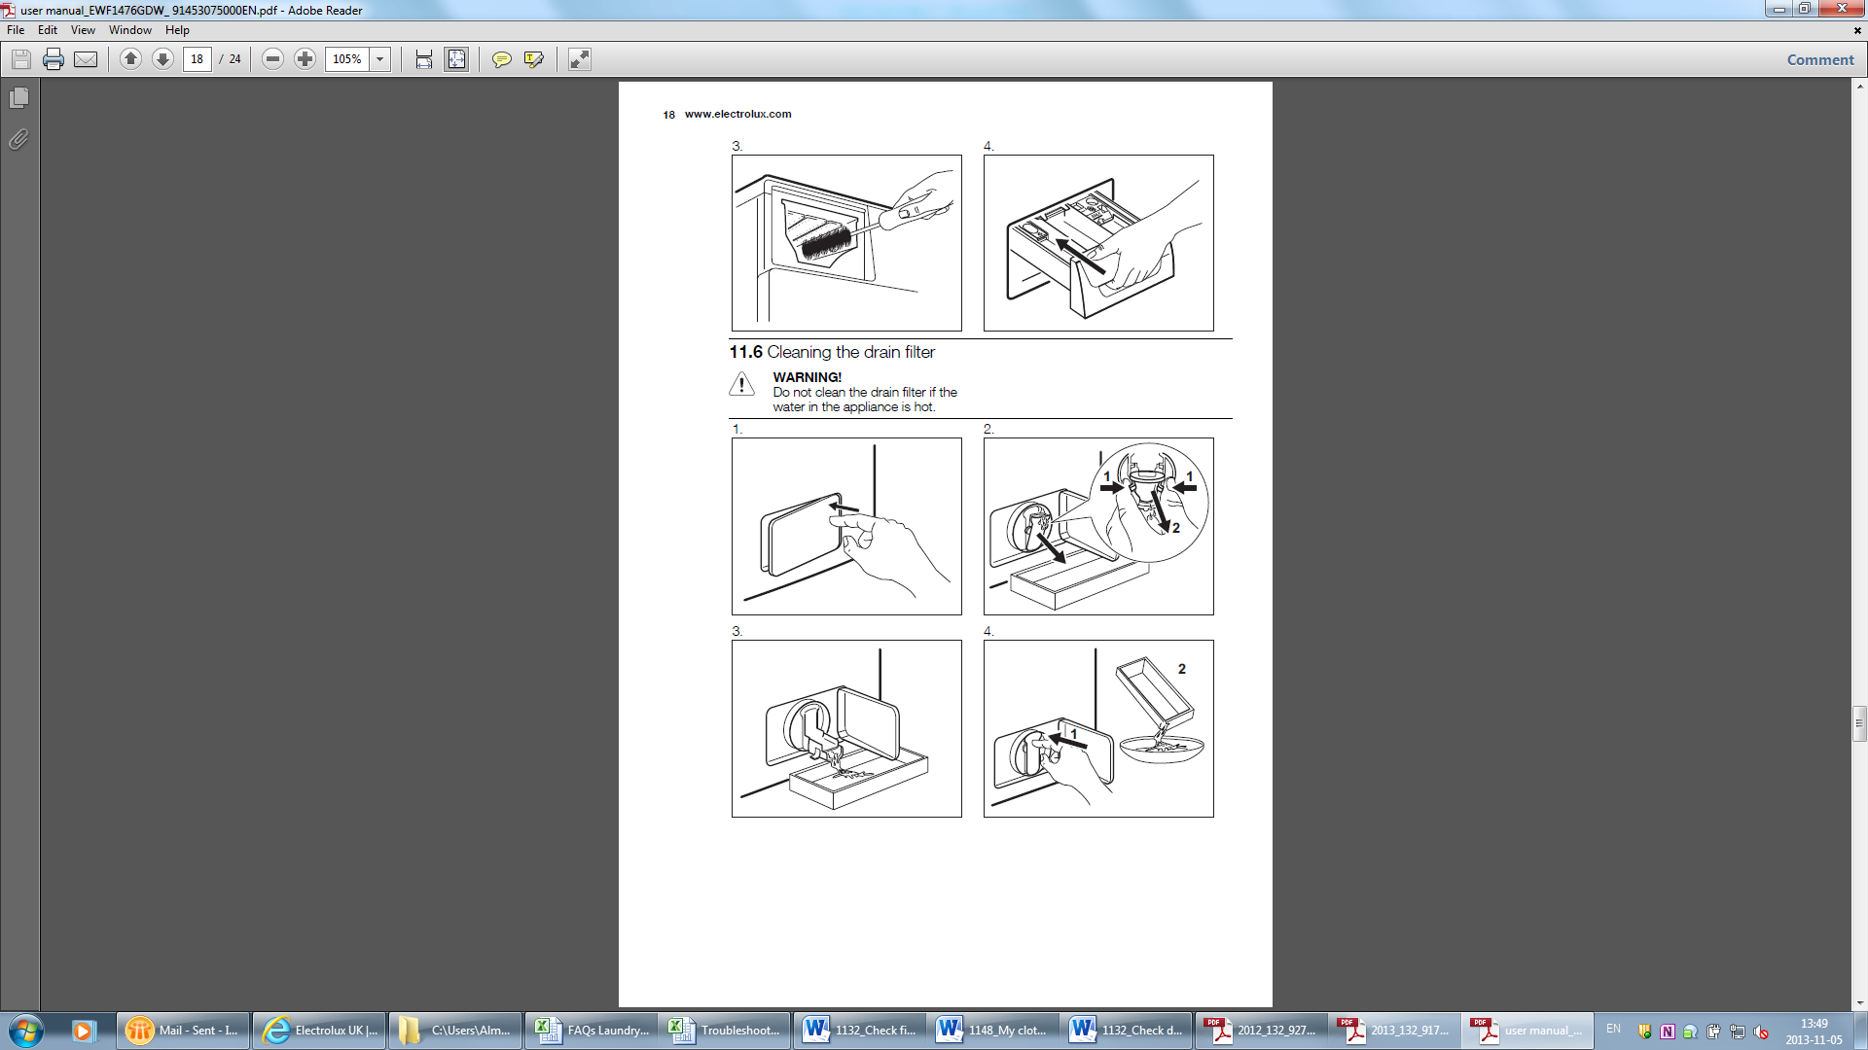

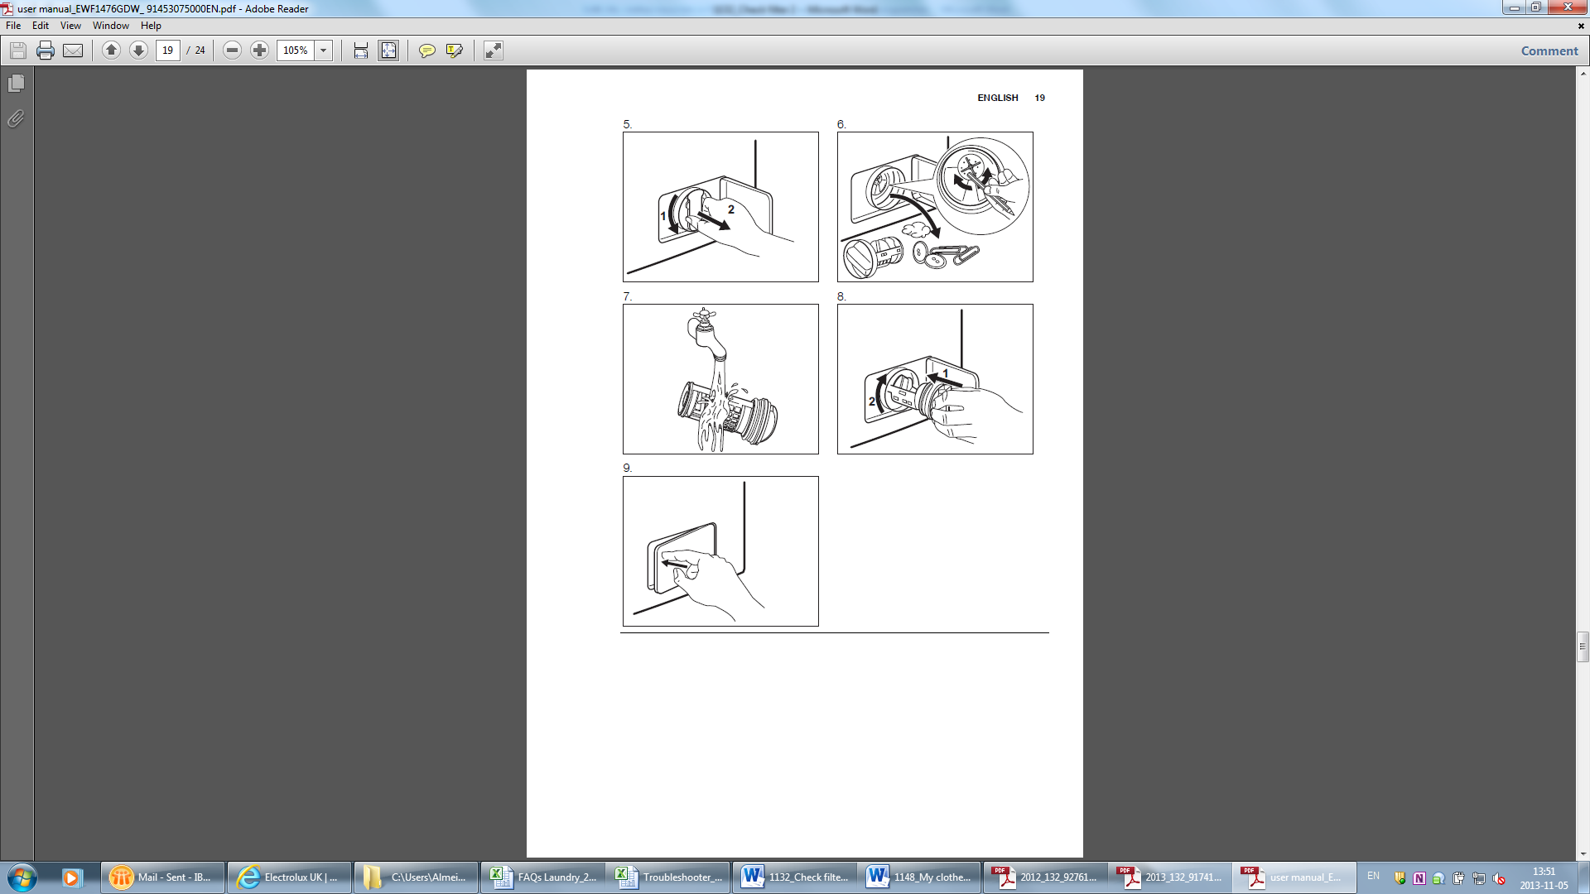

**Washing machines (Filter in drumlifter)**



** **

** **

** **

[Find the specific User Manual for the washing machine.](http://www.electrolux.co.uk/Support/Manuals/)

**KA (additional information)**

Brand Zanussi: In some cases the filter is not accessible for the customer. For cleaning the filter, the customer must book an engineer.